**Homework 5**

Remember that your programs must read the data from the text files exactly as they appear. You may not edit the text files to make them more convenient for SAS. Turn in the code, log file and output. If any of these 3 items is missing then you will not be graded for that question. Use the snipping tool instead of screen shots and make sure the font is large enough for me to read.

1. Refer to CATS datasets. Write a SAS program that creates three separate SAS datasets from CATS1, CATS2, and CATS3 data. Make two new variables which represent the GFR at week 0 for the treated kidney and the GFR at week 0 for the untreated kidney. Print only the cats’ names and the two new variables, identified as “treated” or “untreated” (not “left or “right”).

**CODE-**

libname learn '\\Client\C$\Users\Ultron\Desktop\ISM6930 SAS\Data';

**data** cats1;

infile '\\Client\C$\Users\Ultron\Desktop\ISM6930 SAS\cats1.txt';

input Cat $ Dir $ @@;

**run**;

**data** cats2;

infile '\\Client\C$\Users\Ultron\Desktop\ISM6930 SAS\cats2.txt' firstobs=**2** ;

input Cat $ @**9** Side $ Week0 Week1 Week2;

**run**;

**data** cats3;

infile '\\Client\C$\Users\Ultron\Desktop\ISM6930 SAS\cats3.txt' firstobs = **2**;

input Cat $ Side $ Week0 Week1 Week2;

**run**;

**proc** **sort** data=cats2;

by Cat;

**proc** **sort** data=cats3;

by Cat;

**data** cats23;

set cats2 cats3;

by cat;

drop week1 week2;

**run**;

**proc** **sort** data=cats1;*(rename(dir=side));

by cat;

**run**;

**data** all_cats;

merge cats1 cats23;

by cat;

format treated **4.2** Untreated **4.2**;

if dir=Side then treated=Week0;

else if dir^=side then untreated=Week0;

drop dir side week0;

**run**;

**data** treated untreated;

set all_cats;

by cat;

if treated ^=**.** then output treated;

else if untreated^=**.** then output untreated;

**run**;

**data** all_done;

merge treated(drop=untreated) untreated(drop=treated);

by cat;

**run**;

**proc** **print** data=All_done;

**run**;

**LOG**

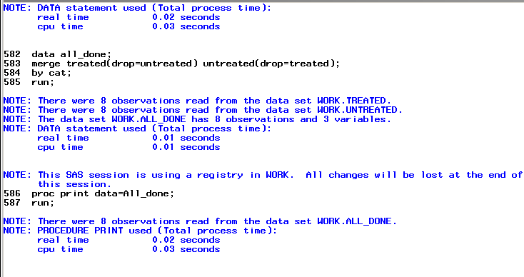

**OUTPUT**

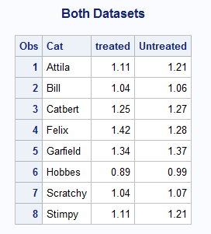

1. Refer to SOCCER dataset. Suppose that the team plans to go to Europe for some exhibition matches, and you need to send their hosts some information about the players. Use a SAS program to convert the players’ heights to meters, then print the players’ first and last names, jersey numbers, and heights in meters. For this question, list only 3 significant digits for the heights (example: 5 feet, 8 inches is equivalent to 1.73 meters).

**CODE**

**data** soccer;

informat lastname $13.;

infile '\\Client\C$\Users\Leland\Desktop\ISM6930 SAS\soccer.txt';

input Jersey $ **1**-**2** / FirstName $ LastName $ /

Position $ /Feet **1** Inches **3** /

Grade $ / Something $;

Height = ((feet\***12**)+inches)/**39.3701**;

**run**;

**proc** **print** data=soccer ;

var firstname lastname jersey Height ;

format Height comma4.2;

**run**;

**LOG**

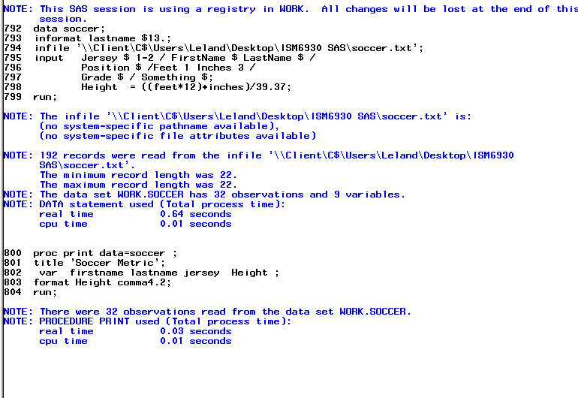

**OUTPUT**

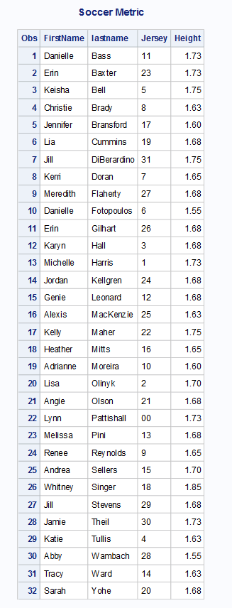

1. There is a mistake in the HOCKEY dataset. The Buckeyes lost to Boston College by a score of 5-2 in their last game. Write a SAS program which reads the data from your USB and corrects the error with programming statements. Read the month, day, and year as three separate numeric variables, and create a new variable for the date by using MDY command. Print the revised dataset and use an appropriate format for the date.

**CODE don’t know how to separate date into separate variables (probable format problem)**

**data** hockey;

infile '\\Client\C$\Users\Ultron\Desktop\ISM6930 SAS\Lesson 4\Homework\hockey.csv' dlm=',' dsd missover firstobs=**2**;

INPUT Game_Date : MMDDYY10.

Team : $27.

City : $17.

State : $13.

OSU

OPP;

FORMAT Game_Date mmddyy10.;

**RUN**;

**DATA** CORRECTED_HOCKEY;

SET HOCKEY;

day = day(Game_Date);

month = month(Game_Date);

year = year(Game_Date);

mdy_date = mdy(month,day,year);

if team = 'Boston College' then OPP=**5**;

if team = 'Boston College' then OSU=**2**;

format mdy_date mmddyy10.;

**RUN**;

**proc** **print** data= corrected_hockey;

title 'corrected hockey';

**run**;

**LOG**

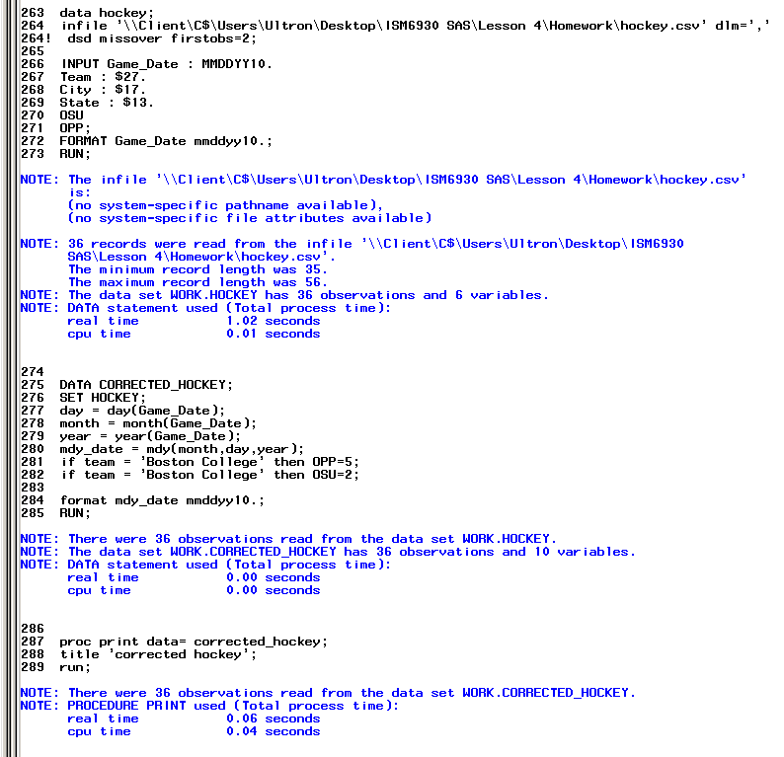

**OUTPUT**

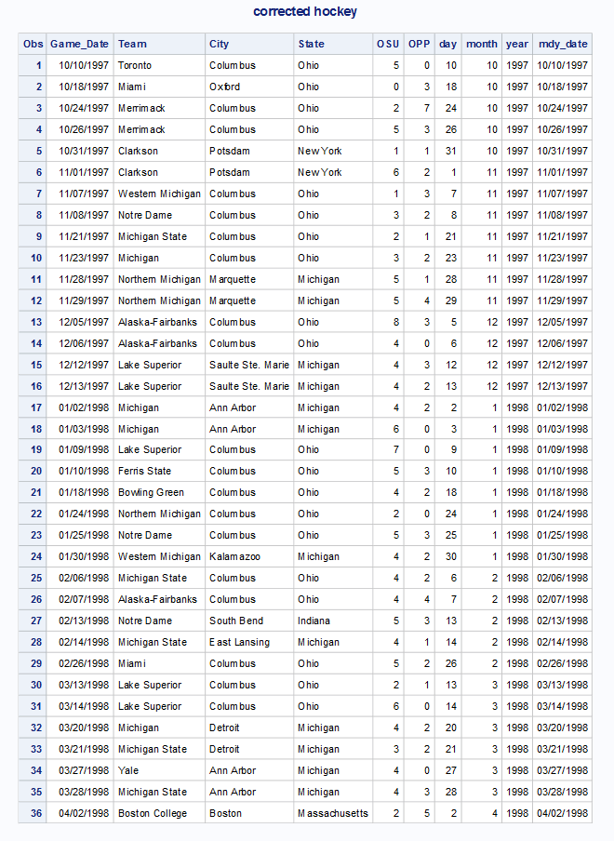

1. Refer to the USEDCARS data. Write a SAS program which reads the full dataset. Then create a dataset which contains only the least expensive car offered by each dealer. Print the new dataset, showing the year, manufacturer, model, price, and name of the dealer. This dataset should have 15 observations, and each dealer should appear exactly once.

**CODE**

**data** usedcars;

infile '\\Client\C$\Users\Leland\Desktop\ISM6930 SAS\Lesson 4\Homework\usedcars.txt'

firstobs=**2** obs=**51** dsd missover;

input Year **1**-**2**

@**9** Manufacturer :$10.

@**24** Model $11.

@**38** Miles comma7.0

@**49** Price dollar10.0

@**61** Dealer $23. ;

**proc** **sort** data=usedcars;

by dealer price;

**run**;

**data** least(drop=miles);

set usedcars;

by dealer;

if first.dealer=**1**;

**run**;

**proc** **print** data=least noobs;

var year manufacturer model price dealer;

format price dollar10.0;

title 'Used Cars';

**run**;

**LOG**

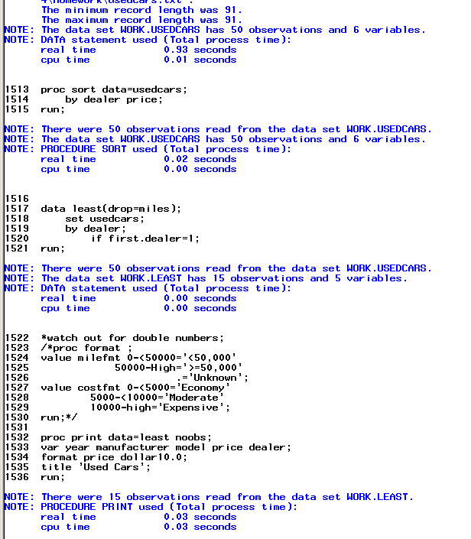

**OUTPUT**

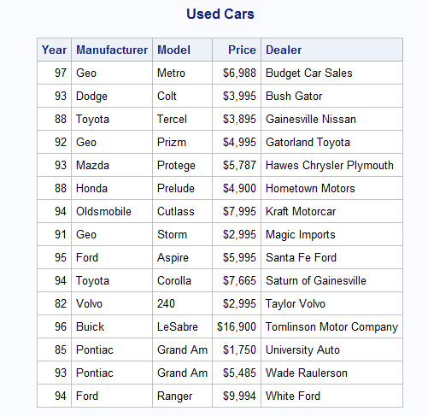

1. Refer to the BREAD dataset. Suppose that you need to create a reference list of bread recipes that do not use eggs (for dietary requirements or preferences, or perhaps you forgot to buy eggs). Create and print a permanent SAS dataset, using LIBNAME and associated commands, which contains only the recipes which use no eggs.

**CODE**

**data** bread;

infile '\\Client\C$\Users\Leland\Desktop\ISM6930 SAS\bread.txt' dlm = ','firstobs = **3**;

input Dough $ Water Oil Sugar Salt DryMilk Flour Yeast Wheat Oregano Eggs;

**run**;

libname homework '\\Client\C$\Users\Leland\Desktop\ISM6930 SAS';

**data** homework.noeggs;

set bread;

**proc** **print** data = homework.noeggs;

where eggs=**0**;

title 'No Eggs Required';

**run**;

**LOG**

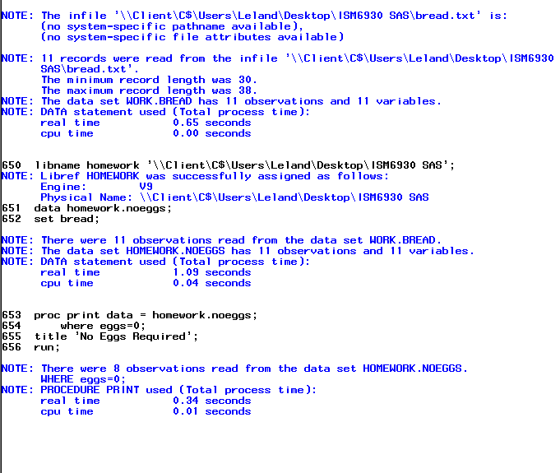

**OUTPUT**

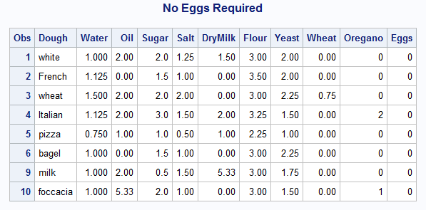

1. Refer to the CLINTON dataset. Gallup has conducted more polls to assess President Clinton’s job approval rating since the CLINTON dataset was created. The data are shown below:

Date Approve Disapprove No opinion

8-18-98 66 29 5

8-20-98 61 34 5

8-21-98 62 35 3

9-1-98 62 33 5

9-10-98 60 37 3

9-11-98 63 34 3

Create two datasets in SAS. One dataset should consist of the numbers in the file CLINTON.TXT and the second dataset should contain the numbers listed above. Combine the two datasets into a larger dataset with the appropriate commands, sort the observations in that dataset in descending order by date (so that September 11, 1998 appears first), and print the larger dataset. Use an appropriate format to print the date variable.

How to merge vars to one date?

**CODE**

**data** clinton;

infile '\\Client\C$\Users\Ultron\Desktop\ISM6930 SAS\Lesson 5\Homework\Clinton.txt' firstobs=**3**;

input @**7** Day **2.0**

Mon $ **10**-**12**

Year **14**-**17**

Approve **24**-**25**

Disapporve **32**-**33**

No_opinion **40**-**41**;

Date_cat = catt (day,Mon,Year);

Date= Input(Substr(strip(date_cat),**1**,**9**),Date9.);

Put Date=Date9.;

Format Date Date9.;

Drop Date_cat;

**run**;

**data** clinton2;

input date MMDDYY8. Approve Disapporve No_opinion;

Format date date9.;

datalines;

8-18-98 66 29 5

8-20-98 61 34 5

8-21-98 62 35 3

9-1-98 62 33 5

9-10-98 60 37 3

9-11-98 63 34 3

;

**run**;

**data** clinton3;

set clinton(drop = Day Mon Year)

clinton2;

*by Date;

**run**;

**proc** **sort** data=clinton3;

by descending date;

**run**;

**proc** **print** data=clinton3;

title 'clinton'

run;

**LOG**

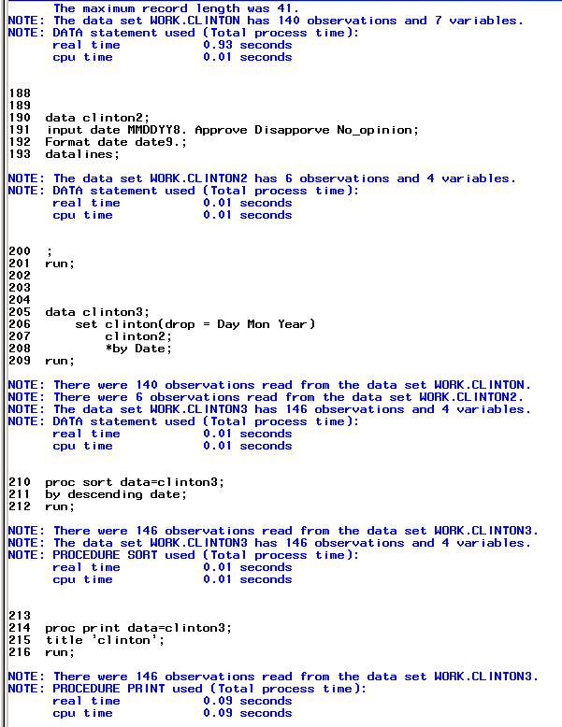

**OUTPUT**

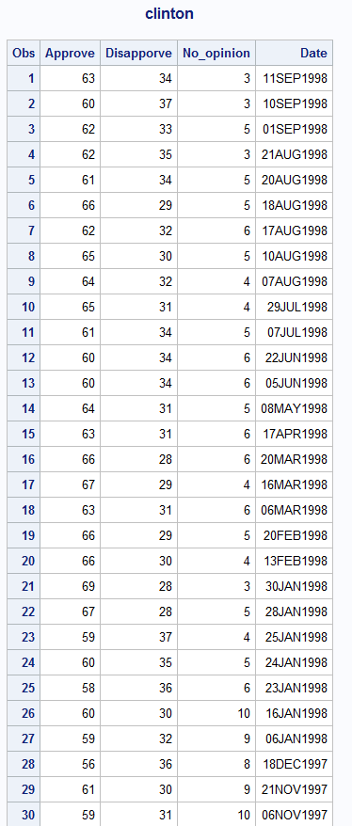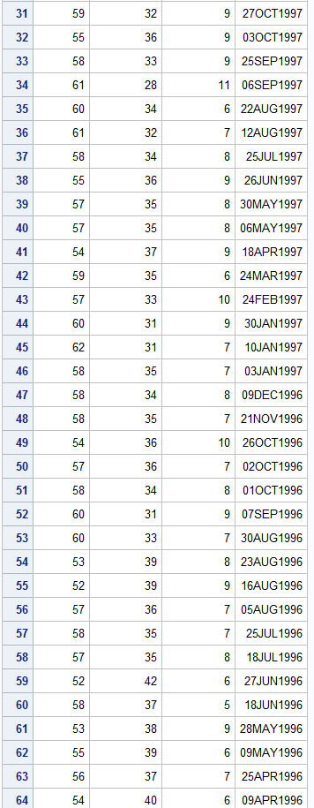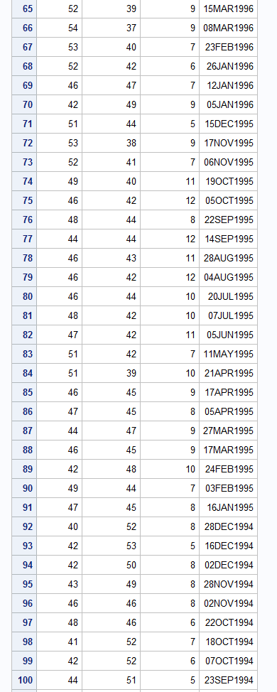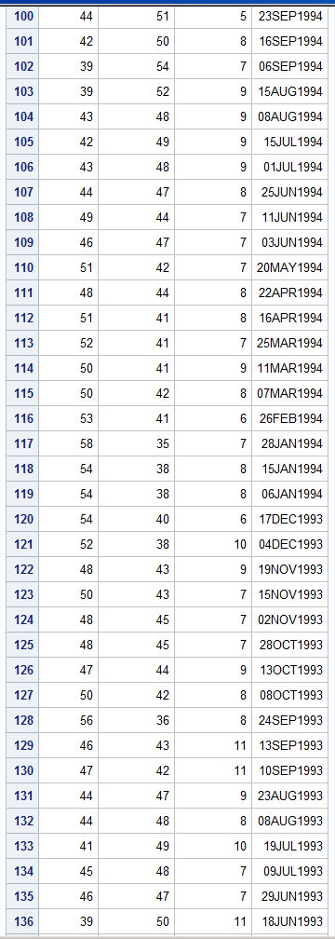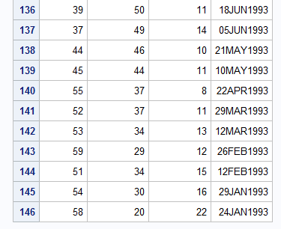

1. Using the SAS data set Blood, create two temporary SAS data sets called Subset_A and Subset_B. Include in both of these data sets a variable called Combined equal to 0.001 times WBC plus RBC. Subset_A should consist of observations from Blood where Gender is equal to Female and BloodType is equal to AB. Subset_B should consist of all observations from Blood where Gender is equal to **Female**, BloodType is equal to **AB**, and Combined is greater than or equal to **14**.

**CODE subset b not showing with the greater than equal to 14**

libname learn v9'\\Client\C$\Users\Leland\Desktop\ISM6930 SAS\Lesson 5\Homework';

**proc** **sort** data=learn.blood out=blood;

by gender;

**run**;

**data** subset_A;

set blood;

where gender = 'Female' AND

Bloodtype = 'AB';

Combined = **.001**\*WBC+RBC;

**run**;

**data** Subset_B;

set blood;

Combined = **.001**\*WBC+RBC;

where Gender = 'Female' AND

Bloodtype = 'AB' AND

Combined>=**14**;

**run**;

**proc** **print** data=subset_A;

title 'subset a';

**run**;

**proc** **print** data=subset_B;

title 'subset b';

**run**;

**LOG**

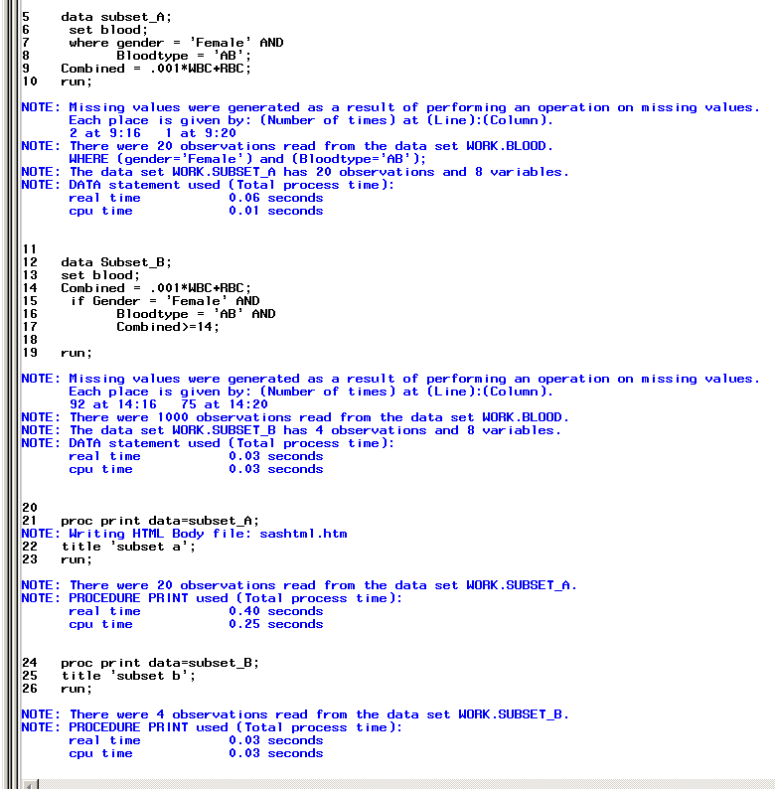

**OUTPUT**

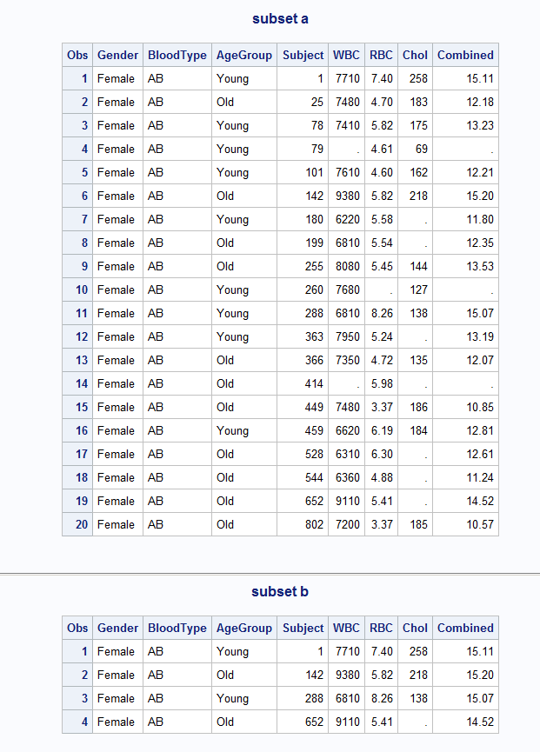

1. Using the SAS data set Blood, create two temporary SAS data sets by selecting all subjects with cholesterol levels (Chol) below 100. Place the male subjects in Lowmale and the female subjects in Lowfemale. Do this using a single DATA step.

Note: Values for Gender are Make and Female.

Careful, some of the cholesterol values are missing. Print the resulting data sets.

**CODE-**

libname learn '\\Client\C$\Users\Ultron\Desktop\ISM6930 SAS\Lesson 5\Homework';

**proc** **sort** data=learn.blood out=genderblood;

by gender;

**run**;

**proc** **contents** data=genderblood;

**run**;

**data** lowfemale lowmale;*temporary dataset;

set genderblood;

if chol <= **100** and chol ^=**.** ;

if gender = 'Female' then output lowfemale;

else if gender = 'Male' then output lowmale;

**run**;

**proc** **print** data=lowmale;

title 'Low Male';

**run**;

**proc** **print** data=lowfemale;

title 'Low Female';

**run**;

**LOG**

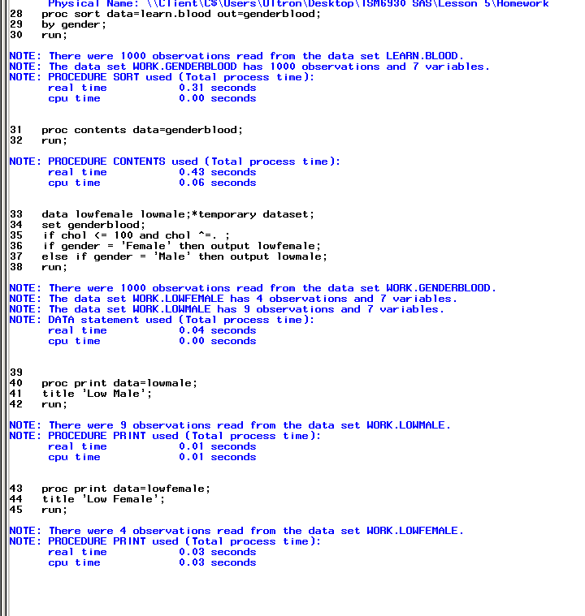

**OUTPUT**

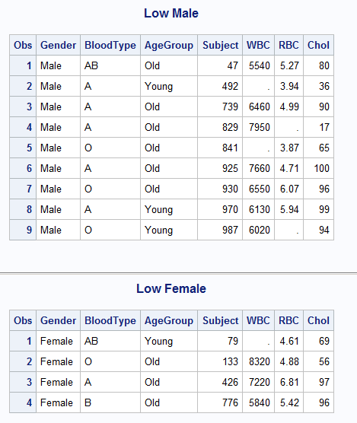

1. Using the SAS data sets Bicycles, create two temporary SAS data sets as follows: Mountain_USA consists of all observations from Bicycles where Country is **USA** and Model is **Mountain Bike**. Road_France consists of all observations from Bicycles where Country is **France** and Model is **Road Bike**. Print these two data sets.

**CODE**

libname learn v9'\\Client\C$\Users\Leland\Desktop\ISM6930 SAS\Lesson 5\Homework';

**proc** **sort** data=learn.bicycles out=bikes;

by model;

**run**;

**data** Mountain_USA;

set bikes;

where Country = 'USA' AND

Model= 'Mountain Bike';

**run**;

**data** Road_France;

set bikes;

Where Country = 'France' AND

Model = 'Road Bike';

**run**;

**proc** **print** data=Mountain_USA;

title 'Mountain USA';

**run**;

**proc** **print** data=Road_France;

title 'Road France';

**run**;

**LOG**

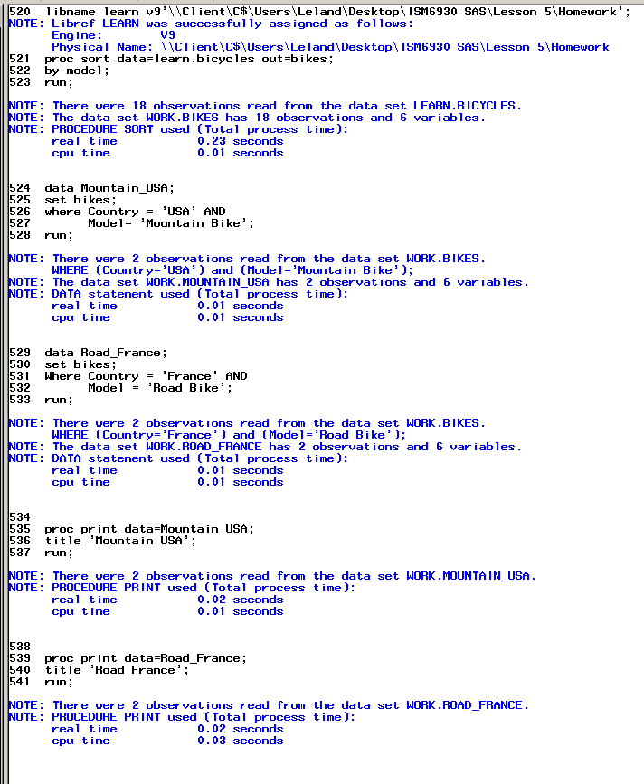

**OUTPUT**

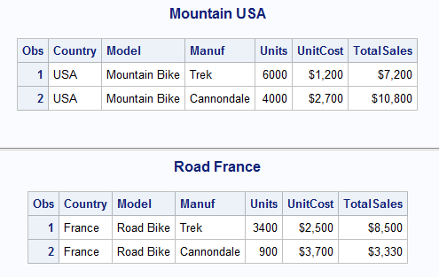

1. Print out the observations in the two data sets Inventory and NewProducts. Next, create a new temporary SAS data set (Updated) containing all the observations in Inventory followed by all the observations in NewProducts. Sort the resulting data set and print out the observations.

**CODE**

libname learn '\\Client\C$\Users\Leland\Desktop\ISM6930 SAS\Lesson 5\Homework';

**proc** **sort** data=learn.inventory out=inventory;

by Model;

**run**;

**proc** **sort** data=learn.newproducts out=newproducts;

by Model;

**Run**;

**Data** combo;

set inventory newproducts;

by model;

format price dollar10.2

run;

**proc** **print** data=inventory;

title "inventory";

**run**;

**proc** **print** data=newproducts;

title "new products";

**run**;

**proc** **print** data=combo;

title "Update";

**run**; 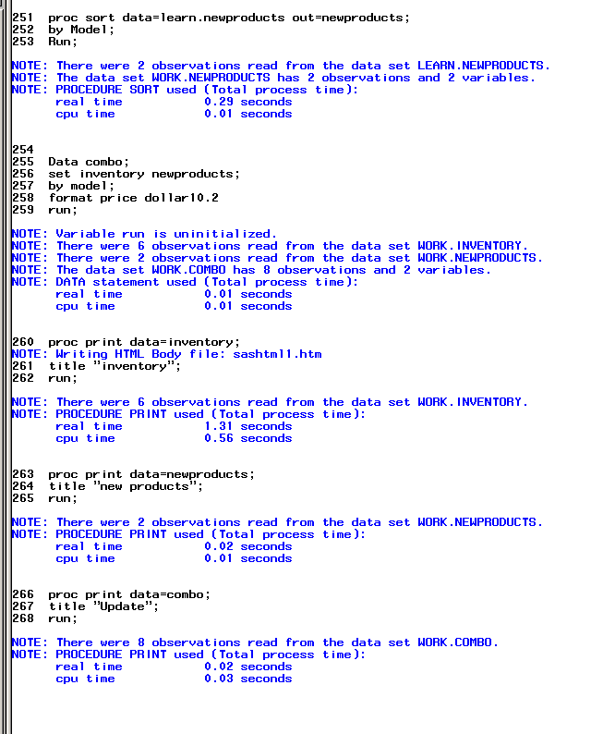

**LOG**

**OUTPUT**

